Internet Of Things

Smart Street Light

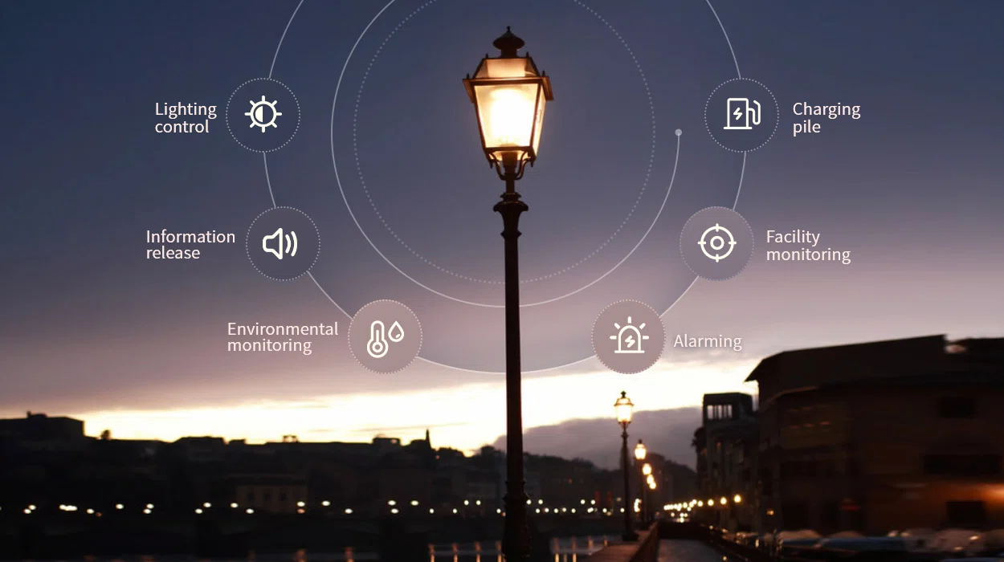

TEAM MEMBERS:

S.Roshini vinnarasi (821021104037)

G.Atchaya(821021104012)

A.Thoumiya(821021104050)

A.Joy Ramila(821021104025)

Problem Statement:

The current state of traditional street lighting systems is inefficient, costly, and lacks smart functionality. Cities worldwide face the following challenges:

1. Energy Inefficiency: Conventional streetlights are often on at full brightness throughout the night, wasting energy when it's not needed.

2. Maintenance Costs: Monitoring and maintaining streetlights can be expensive and time-consuming, with frequent bulb replacements and repair work.

3. Lack of Adaptability: Streetlights do not adjust to changes in ambient light, weather conditions, or traffic patterns, leading to potential safety and efficiency issues.

4. Environmental Impact : Excessive energy consumption contributes to carbon emissions and environmental degradation.

5. Limited Data Insights: Current systems do not provide data for city planning, such as traffic flow analysis, pedestrian safety, or environmental monitoring.

Design Thinking:

To address these challenges and design a smart streetlight system, we can follow these principles:

1. Energy Efficiency: Incorporate sensors (e.g., motion detectors and ambient light sensors) to control brightness dynamically based on real-time conditions.

2. Cost Reduction: Use long-lasting LED lights and remote monitoring to reduce maintenance costs.

3. Adaptability: Implement a system that can adjust brightness and color temperature according to weather, traffic, and pedestrian activity.

4. Environmental Sustainability: Include renewable energy sources like solar panels to power streetlights and reduce their carbon footprint.

5. Data Collection and Analysis: Equip the lights with sensors and cameras to gather data for traffic management, safety analysis, and environmental monitoring.

6. Connectivity: Utilize a robust network (e.g., IoT) to enable communication between streetlights and a central control system.

Conclusion:

A smart streetlight system that addresses the issues of energy inefficiency, high maintenance costs, and lack of adaptability in traditional street lighting can significantly benefit cities. By incorporating sensors, renewable energy sources, and data-driven insights, this system can reduce energy consumption, lower maintenance expenses, enhance safety, and contribute to a more sustainable urban environment. Furthermore, the implementation of such technology aligns with the broader trend of smart cities, promoting efficiency, sustainability, and improved quality of life for urban residents.